MANOSTAT TALENT SOLUTIONS PVT. LTD.
Connecting Talent & Opportunity

Your Trusted Partner in Workforce Solutions | Bangalore, Karnataka
ABOUT US

Manostat Talent Solutions Pvt. Ltd. is a manpower agency support company that provides businesses with the right talent to meet their staffing needs. We understand that finding the right employees can be a daunting task, and that is why we are here to help.
Our team of experienced recruiters uses a comprehensive approach to identify, screen, and select top-quality candidates who possess the skills, experience, and attitude that match your company's culture. We work closely with our clients to understand their unique needs and tailor our recruitment process accordingly.
With our industry expertise, we understand that companies today require more than a skilled candidate — they need employees who are productive, exhibit a positive attitude, and have the ability to become a true member of their team.
We are pleased to introduce ourselves as one of the leading organizations specialized in the field of MANPOWER SUPPLY, registered as a Commercial Establishment under the Karnataka Shops and Commercial Act 1961. We strictly follow all statutory requirements including ESI & PF benefits under Labour Laws.

OUR VISION  To lead in the creation and delivery of innovative workforce solutions and services that enable our clients to win in the changing world of work. |  | OUR MISSION  To provide our clients with the best workforce solutions by delivering high-quality candidates with the necessary skills and expertise, while empowering individuals and building long-term relationships based on trust, integrity, and mutual respect.

OUR VALUES

We give our commitment to a service that at all times:
- Develops and empowers individuals, teams and organizations.
- Provides on-going support and advice.
- Develops programs, processes and systems that fit organizations and meet their needs.
- Provides an emphasis on practical skill development based on proven management theory.
- Is committed to professionalism and excellence.
- Provides clients with value for each dollar invested.

TRUST  Our foundation |  | INTEGRITY  How we operate |  | EXCELLENCE  Quality delivery |  | PROFESSIONALISM  Our standard

OUR SERVICES

We offer a comprehensive range of staffing and recruitment services tailored to meet every client's unique workforce needs:
Temporary Staffing  Temporary staffing solutions for businesses that need short-term support to meet their staffing needs. |  | Direct-Hire Staffing  Direct-hire staffing solutions for businesses that need permanent employees to fill specific roles.
Payroll Management  Payroll processing, tax filing, and related tasks — so you can focus on running your business. |  | HR Consulting  Assistance with employee relations, performance management, and compliance for HR-related tasks.
Professional Standards  We conduct our business following strict ethical standards, maintaining complete confidentiality for all candidates and clients. |  | Workforce Consulting  Strategic advisory services to help businesses plan, manage, and optimize their workforce effectively.

RECRUITMENT TOOLS

- Core Head Hunting and Referencing.
- Job Adverts on all major Job Portals — LinkedIn, Naukri, Indeed, Social Networks and others.
- Creating awareness of Job Adverts on all Social Media Platforms to attract deserving and passive candidates.

OUR RECRUITMENT PROCESS

Our systematic 5-step recruitment process ensures the best match for every role:
- Understand Client Goals
Understand the goals and objectives of our client's business and the open position with respect to projected growth.
- Define Ideal Candidate Profile
Understand the necessary skill set, experience, potential, attitude and aspiration of the ideal candidate required.
- Establish Candidate Search
Quickly and effectively utilize all our extensive search tools, major job portals and in-house database.
- Thorough Screening
Conduct thorough screening through telephonic discussions with each candidate to verify skill, experience, potential and aspiration.
- End-to-End Process Management
Actively manage the entire recruitment process from beginning to end, offering complete support throughout.

INDUSTRIES WE SERVE

We provide manpower solutions across a wide range of industries, enabling businesses of every kind to find the right talent:
🏭  Manufacturing  Industries |  | 💻  IT & Non-IT  Technology & Services |  | 🏥  Hospitality & Healthcare  Hospitals, Hotels & More
🏗️  Construction  Infrastructure & Projects |  | 🏢  Administration  Office & Corporate |  | 🏨  Hotels  Hospitality Sector
🛒  Supermarkets  Retail & FMCG |  | 🧹  Cleaning & Housekeeping  Facility Management |  | 👗  Garments & Textile  Apparel Industry

WHY CHOOSE MANOSTAT?

- Experienced Recruiters: Our team has a proven track record of identifying and selecting top-quality candidates.
- Comprehensive Approach: We use job analysis, candidate screening, and structured selection methods.
- Customized Solutions: We tailor our recruitment solutions to the unique needs of each client.
- Cost-Effective: Our services are designed to help businesses save money on staffing costs.
- Full Statutory Compliance: ESI, PF, Labour Laws — all covered under registered compliance frameworks.

OUR CLIENTS

We are proud to serve some of the most reputed organizations across industries:
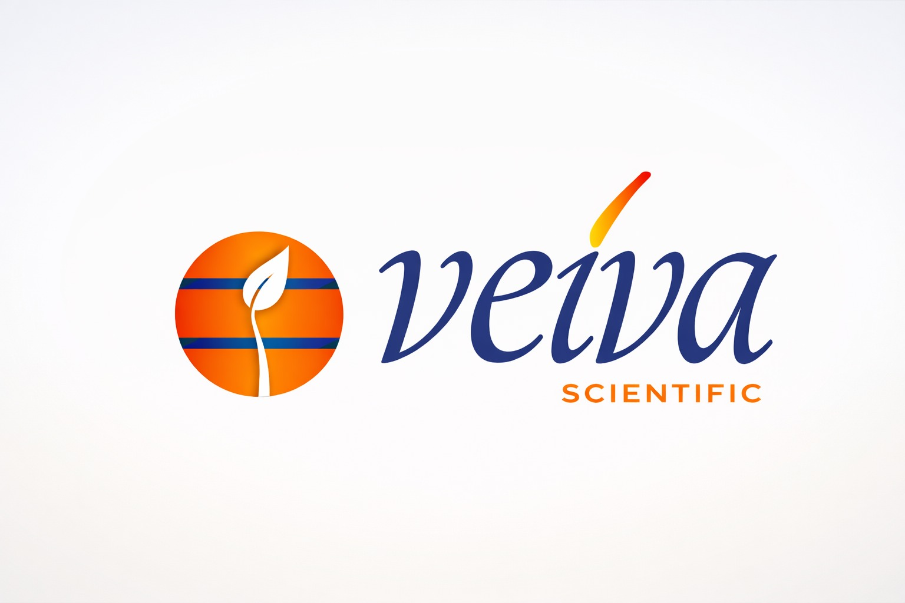  Veiva Scientific India Pvt Ltd |  |   IQF Foods Pvt Ltd |  |   GR Enterprises
  Flipkart |  |   Blinkit |  |   Amazon

STATUTORY REGISTRATIONS

Manostat Talent Solutions is a duly registered entity. The Government has allotted the following registrations:
ESIC No | 53000906340001099
PF Establishment ID | PYKRP3839929000
PAN No | AAUCM4228M
TAN No | BLRM5465D
CIN No | U78300KA2026PTC214773
Labour License | KOL/KOL/CE/0016/2026

CONTACT US

If you are looking for a reliable manpower agency support company to help you find the right talent for your business, contact Manostat Talent Solutions Pvt. Ltd. today. We would be happy to discuss your staffing needs and provide customized recruitment solutions.
Narasimha Murthy R  Mobile: 9538047493  Email: narsimhargowda@gmail.com |  | Office Contact  Mobile: 9538124170  Email: manostattalentsolutions@gmail.com

Address: #1, 1st Floor, Besides Ravi Polyclinic, Vemagal - 563102, Karnataka, India

Ready to find your next great hire?
Partner with Manostat Talent Solutions today and experience recruitment done right.

